Requirement Analysis

Group LTU13B.02

* Nguyễn Văn X
* …

# Use case diagram

## General use case diagram

…

<Image>

Explanation:

Composite use case:

* Manage user
* Manage course

## Use case diagram for “Manage course”

## Use case diagram for “Manage user”

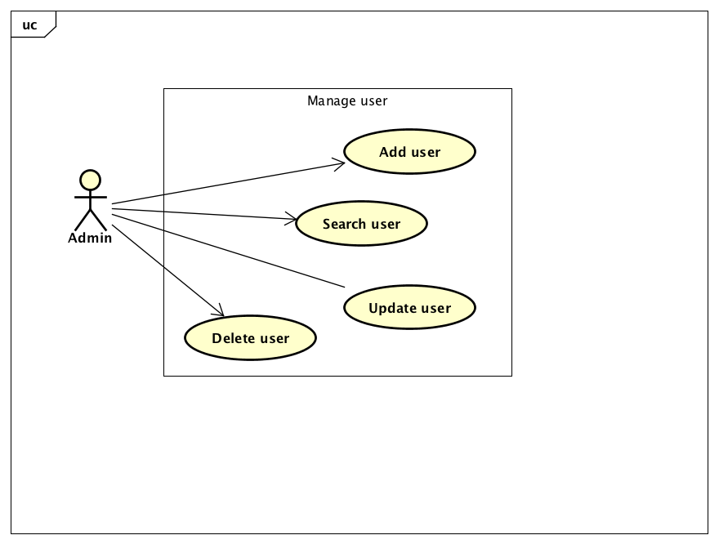

# Use case specification

## Use case “Register for course”

…

## Use case “Close registration”

..

# Glossary

Introduction to Glossary…

## Course

…

## Credit

…

# Supplementary specification

## Functionality

Cxxx

## Performance

Xxxx

## Reliability

…